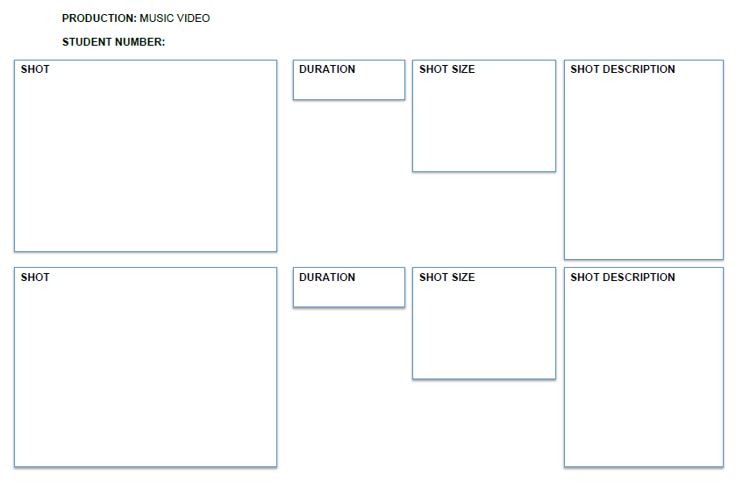
This shot will be introduced by a dissolve from the previous shot and will consist of the artist with projector light to help set the mood. The close-up shots will show emotion in her eyes and the medium shots will show body language.
This shot will cut through several different camera angles and shots including medium and close ups.
0:05
0:04
The opening shot will focus on the piano and will be in black and white. This will be set in the studio to give the video a performance aspect but also sets the mood as quite relaxed and emotional.
This shot will be a close up of the artist playing the piano and will dissolve into the next shot.
BTEC Media Production: Sam
This shot will be a wide shot and will cut to the next shot through a normal cut.
This shot will be a point of view shot and will be a wide shot.
These 5 seconds will be made of a montage of clips, showing a male moving closer to the artist sitting on the sofa. Each shot will fade to black before moving to the next shot showing the passing of time and show of emotion.
0:05
This shot will be a point of view shot from my artist, towards the TV. The lighting will be dull to set the mood and I will use candles as the main source of light. I will use a blur to change the focus of the shot from the TV to the candles.
0:03
This shot will be a long shot to show the artist in a crowd/group.
This shot will be an over the shoulder shot, therefore a close-up of the artist’s phone.
0:03
0:03
This shot will show the artist happy and socialising with friends. The lighting will be light and positive to show her happy mood. I will use a dissolve transition to a c timelapse of a clock to show passing of time.

This shot will be an over the shoulder shot of the protagonists phone, showing a text message from a male saying how he loves her. I will then use a diagonal pan to reveal the artists facial expressions. Lighting will be dim.
This shot will start as a long shot but cut to a close-up.
This shot will start as a close-up but explore different shots and angles. Movements will include slow pans.
0:03
0:03
This shot will be handheld and will show the artist driving in darkness, portraying anger and upset. The shot will cut abruptly to her dashboard showing her speed increasing. This will represent her upset/anger.
This shot will start as a close up of a clock, slowly panning diagonally to the artist crying, next to her, her phone with a text telling her to leave the male protagonist alone. The lighting will have faded back to dull to show her drop in mood.
This shot will be a mid-close-up shot, as it will be a reflection of the artist.
0:03
This shot will show the artists reflection in the water to relate to the lyrics and imply she doesn’t know who she is anymore. This transition will involve the use of colour change, probably fading to white.
This shot will use a projector image in the background, but also a red gel cover over the lighting to portray her emotion and give the metaphorical idea behind the lyrics at the time, I will use a dissolve transition.
This shot will be a vertical pan of the artist and will finish as a close-up shot of the artists heart.
0:04
This shot will be a wide shot, just like previously, to get the mis-en-scene and the actors.
0:02
0:03
This shot will cut back to the male protagonist moving closer to her on the sofa to keep the narrative moving and keep the audience interested. Again, lighting will be dim and slightly blurred to show her confusion of emotions.
This shot will be a close up of the artist whilst she is singing. I will use black and white throughout the performance to show emotion.
This shot will be of the artist whilst she is performing to show the audience the passion and emotion she is feeling whilst singing the lyrics. I will use a straight cut to transition in to the next shot.
This shot will be an establishing shot and will be a straight cut.
0:03
0:03
This shot will suggest the artists feeling, as we will see the location before the next shot of her cutting the rose. This will give the audience information and help to set the mood (eg. Isolation).
This shot will start off as a medium shot, then will change to a POV shot, and finally a close up. This passes time and will relate to the confusion the artist feels throughout the song.
This shot will show the artist receiving gifts from the male suggesting that he is being nice to her. I will use a medium shot of her opening the door to see the gifts, followed by a point of view shot of her looking at the card given, before finally ending with a close up of her to show her confusion of receiving the gifts.
0:03
0:03
This shot will be a head on mid shot, the camera will be still.
This shot will be a POV shot before cutting to an extreme close-up. . The close-up will be at a slight high angle.
This shot will show the artist stood in front of a projector full of stars, and will cut from a medium shot to a close-up of the artist quickly drinking red wine. I will then use an extreme close up of the empty wine glass, this transition will be a straight cut.
This shot will show the artist cutting up the rose left with the gifts, and will cut from a POV shot to an extreme close-up handheld shot of the artists face to show her emotion and anger growing. This will represent the destruction of not only her emotion but the physical representation being shown for love.
0:03
0:03
This shot will be at a slight left angle and will be in slow motion. As it will be an action shot it will be tracking the artist slightly
This shot will be a straight on close up, before panning left in slow motion.
This shot will be of the artist hitting a wine glass off of the table with anger and force to show her build up of emotion. As the shot will be in slow motion, when the glass smashes, it will have more of an effect on the audience as they will have longer to be shocked at what they have just seen. I will cut to a close-up of the artist crying.
This shot will be an extreme close-up of the artists lips as she moves her finger along them, leaving a mark of red wine. This will relate to the lyrics and keep the audience interested, as it is showing that she wants to be just like him. I will move to the next shot via a slow motion pan, as the next shot will be in slow motion.
0:03
0:03
To end the chorus, I will have a shot where the audience is looking down on her, showing her exhaustion from running and her emotions in general. This will help portray emotion, especially as I will use several shots her of her looking in different directions, all overlapped opaquely.
This shot will be a high angle close up shot and will use straight cuts to flick between shots.
This shot will be a long shot, and will cut to a tracking shot of the artist running.
In the previous shot I will show the artist departing the scene running, but in slow motion. This will then cut to this scene where we see a long shot of the artist running across a field. This will imply that she is running form her emotions and she has “lost herself”.
0:03
This shot will be an extreme close-up to the artist showing a tea on her face. This shot will fade to black to show the end of the film.
This shot will be a handheld mid-shot. To end the video this shot will fade to black.
This shot will be a close-up shot and will use a slightly high angle.
To end the song, I will show her playing the piano, the colour will fade from black and white to the same shot with a blue gel cover over the lighting. This will imply her numbness and will suggest she now has no emotion. I will dissolve into the next shot which will be blurry suggesting she is physically drunk.
0:04

