Unit 42 Task 1: P1 –
Understand the Structure and Organisation of UK TV Broadcasting

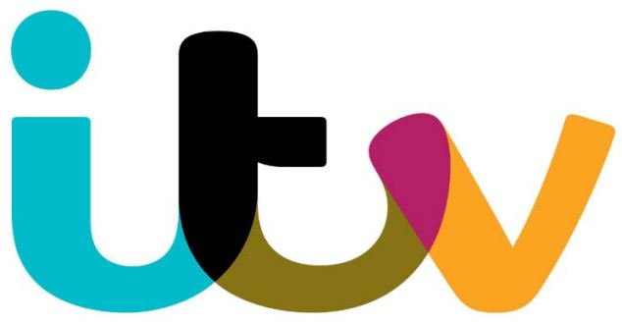


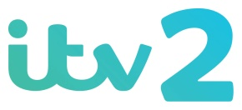

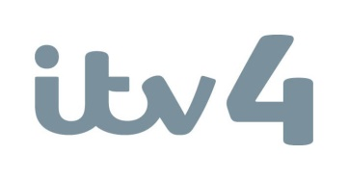
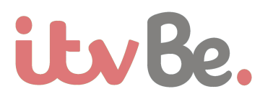

OCR Film and TV Production
Charleigh Hobbs
January 2017

Public service broadcasting is the release of programmes that are of benefit to the public rather than for just commercial purposes, for example local news coverages, religious broadcasts. TV and radio broadcasters must include a certain amount of public service broadcast as part of their broadcast license. Commercial broadcasters are those who show advertisements etc to promote an idea or product that will gain them profit as a result of audiences watching and therefore buying the advertised product. The advertisements fund their broadcasting operations to enable them to make profit. The Broadcasting Services Act explains that Commercial Broadcasting services must provide programmes that are intended to appeal to the general public, are easily received by any member of the general public, are free, are usually funded by advertising revenue and are operated for profit, or as part of a profit making enterprise. Sometimes, commercial broadcasting is also called private broadcasting.
ITV is part of the Channel 3 service family and is therefore a commercial service, for the public. ITV first began broadcasting in 1955 on channel 3 in the London area. By 1973 there were 15 separate channels and 3 regional broadcasting licences- each of the regional licences were run by a separate company. In 2004 Granada plc and Carlton Communications merged to create ITV plc, the company which owns the Channel 3 broadcasting licences (including ITV) in England, Wales, Southern Scotland, the Isle of Man, the Channel Islands, and Northern Ireland. Programming on ITV is primarily funded by television advertising revenues- ITV has the largest share (ITV plc estimate) of the UK television advertising market at 46.1% in 2015.
The board of directors consists of 8 men and women and is led by Sir Peter Bazalgette. They oversee the workings of the management team, consisting of 9 men and women, in the interests of the shareholders. The board of ITV plc is committed to business integrity and high ethical values across the group’s operations. ITV’s main strategic priorities were reviewed and renewed in July 2014 and are now to: maximise audience and revenue share from free-to-air broadcast and VOD business, grow international content business and build a global pay and distribution business. ITV is the biggest marketing platform in the UK therefore reaching around 80% of the television owning population every week. ITV have unbeatable ability to deliver mass audiences across all demographics. ITV is also focused on maximising the value of its airtime and new revenue streams through sponsorship, interactivity and branded content.
In the UK, TV Broadcasting is roughly 50% free-to-air and 50% pay. Free-to-air television is delivered through the services Freeview, YouView and Freesat, while pay television is delivered through the satellite operator Sky and cable operators Virgin and BT. Pay television is still a huge part of society; however competition is starting to grow with regards for pay television providers such as Sky and Virgin. BT, Netflix and Amazon are becoming more and more popular, therefore creating competition for the pay TV providers, threatening their revenue. More and more home owners are replacing their free TV with other forms of paid content including subscriptions to On Demand viewing such as Netflix, or buying extra channels and features from providers such as Now TV. ITV participates in the pay television market, earning revenue from third parties such as Sky and Virgin through the licensing of channels and their content. ITV have recently introduced their own pay television channel, ITV Encore, where series are replayed throughout the year, alongside their HD channels, which also generate revenue. ITV gains revenue through advertisements and works alongside agencies to create commercial partnerships and sponsorships. Audience interaction also creates revenue for ITV through competitions and voting (for example the X Factor). ITV choose to spend a large amount of money on original programmes so international broadcasters will want to purchase the rights to them for their audiences, therefore creating revenue. Finally, ITV also have an advertising free subscription version of the ITV Hub on iOS and a deal with Sky to make ITV’s content available through its connected platforms including SkyGo.
Product Placement is when a company pays a TV channel or a programme-maker to include its products or branks in a programme. For example, the use of clothing brands in a TV show is only allowed with the permission of the brand owner. This may mean that the brand itself pays the company to feature it in a TV programme to promote its brand. However, not all brands have been paid for. Programme makers also use ‘props’ to dress a set in a TV show, for example Emmerdale. The difference between product placement and the use of props is that the TV channel and the programme maker don’t receive any payment for including props. They pay to use them or get them free, rather than being paid to include them, so they’re not product placement. Product placement within film sand international programmes has been allowed on UK TV for many years. From February 2011, TV Programmes made for UK audiences can contain product placement as long as they comply with Ofcom’s rules. These rules apply to all programmes broadcast on channels licensed by Ofcom and include some channels that broadcast outside of the UK.
The Ofcom Broadcasting Code includes many rules for product placement to determine what type of products can be placed in programmes, where product placement is allowed, and how place products can be featured. Ofcom’s Broadcasting Code consists of 10 sections and covers topics and issues that are limited to the public. Protect the under-eighteens is the first section within the broadcasting code, and aims to protect those under the age of 18 from any harmful or offensive material that may seriously impair the physical, mental or moral development of them. This may include drugs, smoking, alcohol, violence, dangerous behaviour, offensive language, exorcism, nudity and sexual offences/nature. The Ofcom Broadcasting Code sets standards for television and radio shows with regards to what can be shows on TV before the 9pm watershed. This is a great way of protecting those under the age of 18 as anything unsuitable for children cannot and will not be shown before 9pm. Section 2 covers prevention of material that will cause harm or offense by limiting the amount and content of violence, dangerous behaviour, suicide, exorcism, the occult and the paranormal in TV. Crime, disorder, hatred and abuse are also a key focus within the broadcasting code, as it encourages broadcasters to express the right to freedom of expression and audiences’ right to receive information and ideas. Broadcasters need to ensure that any content is not going to encourage or incite audiences to commit crime/discouraged behaviour, for example descriptions or demonstrations of criminal techniques which include essential details. The respect of religion and religious programmes is also hugely important within the broadcaster’s code; broadcasters must respect all religions to avoid discrimination or denomination. Accuracy is also a main focus for broadcasters, as it is crucial that whatever form of news is reported is reported accurately and presented with due impartiality. Significant mistakes should be acknowledged and corrected on air quickly, and no politician should be used as a newsreader, interviewer or reporter in any programmes, unless it is editorially justified. Rules for referendums and elections also apply to follow requirements in the Communications Act 2003. Section seven covers Fairness and is to ensure that broadcasters avoid unjust or unfair treatment or individuals or organisations in programmes. Section 8 covers Privacy; it ensures that broadcasters avoid any unwarranted infringement of privacy in programmes and in connection with obtaining material included in programmes. Privacy focusses on how broadcasters treat individuals or organisations during and after production. Section 9 gives broadcasters editorial independence and control over programming. News and Children’ s, Current Affairs, Consumer Advice and Religious shows are all banned from Product Placement in conjunction with the Broadcasting Code for Product Placement. Tobacco, Alcohol, HFSS Brands, Gambling, Baby Milk, Medicines and any product that isn’t legally allowed to be advertised on TV is also banned from Product Placement as a result of the Broadcasting Code.
ITV have aired 4.500 hours of Product Placement. Examples include Interflora in Coronation Street and Ministry of Sound in Love Island. Other ITV programmes including Product Placement include This Morning, The X Factor, Emmerdale, The Biggest Loser and Dancing on Ice. Product Placement is a huge feature of Coronation Street; ITV offer a package that includes prime-time product placement in the Coronation Street bus shelter, a key location in the show. This means a 3 week-long slot per brand, a minimum guarantee of 10 seconds on screen during the deal period and an investment level of £30k gross per 3 week campaign. In addition to the poster in the bus shelter, brands are allowed to publicise the Product Placement on social media during the 3 week-period. 2 cleared images of the poster on set with be shown after advanced warning of good PP exposure on screen. The brand will be able to co-ordinate the timings with the posts. Product Placement is key on a show like Coronation Street as episodes reach an average of 8.1 million viewers. They have 3.2 million social media followers, and it’s the 3rd largest show on commercial TV this year for Housewives and Women. In a Case Study conducted by ITV in 2010, 91% of Coronation Street audiences stated that seeing the brands in the programme made no difference to their enjoyment of the show.
A sponsored programme is one that has some or all of its costs met by a sponsor with a view to promoting its own or anothers name, brand, product or service. Sponsorship is allowed for a whole programme or for programme segments, or for a whole channel. Prohibited sponsors aren’t allowed to advertise on television and therefore aren’t allowed to sponsor TV channels or content. This may be because of the political nature or brands that promote tobacco, for example. Restricted sponsors are advertisers that aren’t allowed to advertise on that specific channel, and therefore cannot sponsor a programme of that channel.
Sponsors of ITV programmes throughout 2016 include Aunt Bessies on I’m A Celebrity… Get Me Out of Here!, Suzuki Vitara on Saturday Night Takeaway and SSE for the coverage of the Rugby World Cup. Over the past few years Amazon have also partnered with Downton Abbey, and Pets at Home have sponsored Paul O’Grady’s for the love of dogs. A strategic link between the brand and programme is key. For example, Ladbrokes has previously sponsored the Europa league, because the programme implies betting and gambling due to results. This is a strategic link due to target, occasion and product match. A Category match sponsor may include Anchor sponsoring Food glorious food, and a brand values/synergy target match may include Tesco finest sponsoring Downton Abbey.
ITV broadcast several genres including Drama, Entertainment, Factual, Film and Sport. In 2015 the most watched entertainment show was Britains Got Talent with an average of 10.5 million viewers across the series. The most watched soap was Coronation Street with an average of 8 million viewers, the most watched drama was Downton Abbey and the most watched sporting event of 2015 was the England vs Wales matched during the rugby world cup, with 9.7 million viewers. ITV launched a number of new entertainment shows including Nina Warrior UK, Mission Survive and You’re back in the room. Returning shows brought huge audiences and new dramas such as Code of a Killer, Safe house and Home Fires also delivered large scale audiences. In 2016, ITV delivered 50 hours more drama than the previous year with new series such as Victoria, Cold Feet and Brief Encounters and also hosted the rugby six nations- spend on UK drama has increased by 12% since 2014, whereas send on children’s TV, arts and classical music and religious programming has decreased. ITV was rated statistically significantly higher than all PSB’s as 78% of viewers claimed ITV produced ‘high quality soaps and dramas’ and that ‘news programmes are trustworthy’. 62% of viewers said that ‘it portrays (my) region/nation fairly to the rest of the UK’ (ITV Media, 2016). Returning programmes included Vera, Endeavour, X Factor, I’m a celebrity get me out of here, Love Island, Long lost family, the chase and the tour de France. In 2016, ITV showed the most watched entertainment show, I’m a Celebrity with 12.7 million viewers on 13th November. Coronation Street was the most watched soap on any channel with an average of 7.6 million viewers, the most watched sport was Englands match against Iceland on the 27th June which was shown on ITV and averaged 15.2 million viewers- from kick off to the final whistle showed a peak of 16.9 million viewers. The most watched current affairs programme was the Europe Referendum Debate which was hosted by ITV and watched by 4.4 million on the 7th June (BARB 1st Jan-27th Nov 2016).
ITV Studios have recently gained links with Mammoth Screen and Twofour Group, 2 successful production companies, therefore strengthening the ability to increase production across all genres. ITV have produced series such as The Graham Norton Show (BBC1), 24 Hours in A&E (Channel 4), 10,000 BC (Channel 5), Poldark (BBC), The Voice (BBC), Educating Cardiff (Channel 4) and Posh Pawn (Channel 4).
ITV broadcast traditionally on ITV (channel 3), and on digital channels such as ITV2 (launched 1998), ITV3 (2004), ITV4 (2005), ITV Encore (2014), ITVBe (2014), and CITV (2006). In additional to linear broadcasting, ITV delivers content across multiple platforms; the ITV Hub, ITV’s Website, ITV.com, platforms such as Virgin and Sky and through contract deals with services such as Apple, iTunes and Netflix. The most recent platforms that ITV content has been released on include Amazon Fire, YouView Sony and Freeview Play. ITV’s content is now available on 27 platforms. Changes in technology have increased audiences interest in on demand viewing. In November 2015 the ITV Hub was launched to replace ITV Player and ITV.com across mobile and PC through which audiences can access ITV content on different devices, live or on demand. There have been 21 million downloads of the ITV app and therefore 13 million registered users of the ITV hub (Stats of 2015). ITV strive to build the ITV Hub with improvements in technology and new content such as premieres, box sets and short-form content.
Broadchurch was a huge drama for ITV and first aired in 2013. To introduce the series Broadchurch showed a montage of shots that used enigma codes to attract the audience. The show opens with a close up of the sea where the waves are rough, which instantly implies to the audience that there is uncertainty from the start. The sea normally connotes an unpredictable manner and a sense of mystery as nobody knows what happens in the ocean, which relates to the narrative/genre of the drama. The next shot shows a track in of an empty street, with the only lighting being street lights. The police station is also dark with 3 points of bright lighting and is iconographic for the genre. Everything is dull and dark and there is hardly any colour enhancement to show the negativity and mystery of the series. The bus stop reads “love thy neighbour as thyself” which is an enigma code (Barthes) as it is a religious reference that all will know of but that the audience will question as to why it has been used. It’s hugely applicable to the narrative, as the community comes together as a result of the murder investigation, but actually it becomes irony as the murderer was the family’s best friend, and therefore can be labelled as a neighbour. The first episode follows Todorov’s narrative theory, as we see the equilibrium of a typical night; streets are quiet, the sea is still awake, all the lights are off and people are asleep. Time is ticking, and we see a small male figure stood centre of the shot before a close up of blood dripping from his hand. A tracking shot becomes an aerial shot as we see the height at which the male is stood. The scene is set and the narrative begins, with the mum waking up and looking at the clock to find that the clock has stopped ticking and is stuck on 3.20am. This is iconography for the idea that time stopped for her then, as this is when her son was murdered. Typical iconography of the crime genre is used throughout, such as investigation teams, offices and police tape. Props are used for iconography; however audiences didn’t pick them up because they were also hidden clues of the murderer. Handheld shots are used heavily to portray emotion and involve the audience as much as possible, so that audiences can relate to the narrative.

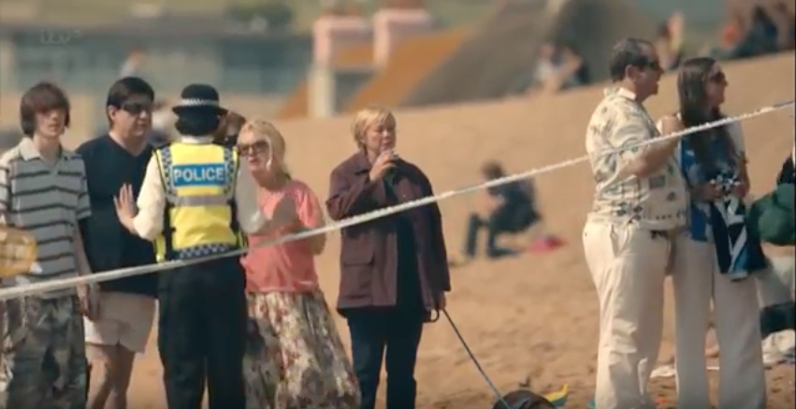
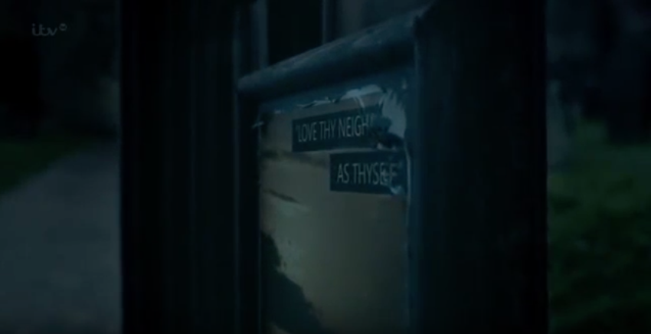
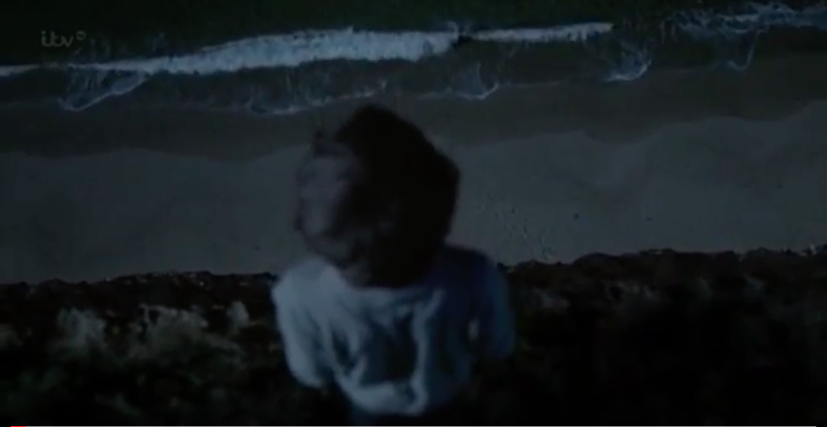
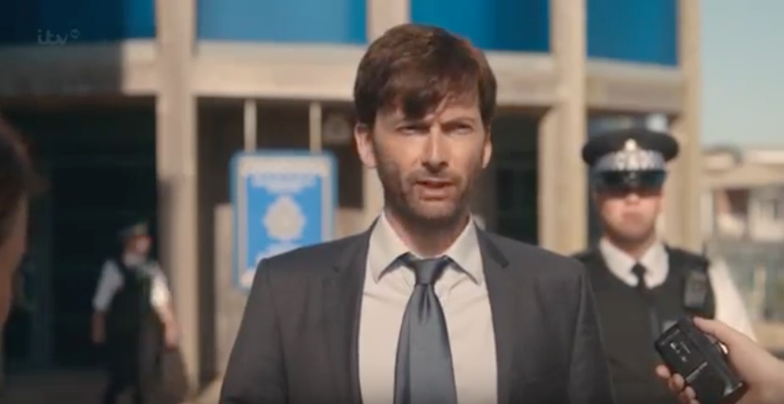

ITV just like any other channel have to go through several production processes in the creation of original programmes of any genre. For example in Broadchurch (series 1), a drama shown on ITV in 2013, pre-production was an extremely lengthy process. The writer spent months working on the storyline, as he was determined not to create a “who done it” storyline for the audience, but something more realistic and exciting. For example, originally, one of the main characters, DSI Ellie Miller was a lesbian, however this didn’t work to create audience response, therefore the writer added extra characters. This not only created more mystery, but also added the impact on the audience as it focussed on how grief and murder affected each character related to the victim. He created a fictional newspaper to add reality to the drama, and several other typical conventions of the genre that made it as realistic as possible to connect with the audience.
Only the first few episodes of Broadchurch series one were written before filming began. Originally the programme was pitched to the Pay TV channel Sky Atlantic, however the writer (Chibnall) was determined that the project was good enough to sell to ITV. ITV enjoyed the idea of Broadchurch and wanted it to air in early 2013, so filming took place in summer 2012. This made the pre-production schedule incredibly short. Most of Broadchurch was shot on one location as producers felt it would heighten tension and reality of the series. Locations included Somerset, Dorset, Gloucestershire and Bristol.
Only two shots in the whole of series one used a green screen- both were filmed at Waterloo Film Studios in London. Broadchurch was shot in order to keep the tension high with regards to the storyline. There were minimal rehearsals as producers wanted situations to be improvised so that characters were 100% in character and dramatized their original reactions. Improvisations meant it was more difficult for the technical crew, however producers knew this would reach maximum audience reaction. The director of the first series approached it as more of a documentary film to create a landscape for audiences. Handheld shots were used to help create tension between characters and to create enigma for the audience and keep the tension high. There are several clues of the murderer throughout, although all through iconography, therefore meaning that the audience were unaware of it, for example the slug in the miller household at the start of the series implied something was wrong within the family. Visual style was hugely important for the producers as secrecy was key, but so was visual and technical accuracy and emotional response.
Audio post-production was handled by Sonorous. They identified sound which needed work and improved any sound for impact on the audience. To maintain secrecy actors had to loop dialogue without seeing the visual situations. The first episode was seen by an average of 9.1 million viewers, with an average weekly audience of 7.1 million “live” viewers. Since the series, it has aired on BBC America and on iTunes and Amazon.com.
In November 2016, 23.35% of viewing was on ITV, which is the second highest figure falling below the BBC at 32.24%. ITV have several main audiences; female, male, upmarket, broad, young and housewives with children. ITV has a range of target audiences for a range of purposes and targets. ITV target a broad audience, but also specific audiences such as housewives with children. For example, Coronation Street’s target audience is females, and a broad audience. This is partially down to the genre, as dramas are often aimed at women, due to the fact that now women are equal in society and complete long working lives, they enjoy the escapism that a drama such as Coronation Street provides (Katz and Blumler, 1974). This drama represents everyday situations and therefore is easily relatable for working mothers, yet gives the sense of escape as they don’t have to deal with the issues that the characters face. A drama like Victoria also has a broad target audience of the ‘upmarket’. This is also down to the genre, however is hugely down to the mis-en-scene and narrative. The story is about the royalty, and therefore would appeal to those who are of a higher working class, but also those who believe they are higher within society, such as older people who have experienced some if not all of the life of our current Queen. In an average week, ITV reaches 75% of ABC1’s, 73% ABC1 men, 66% 16-34’s, 71% 16-34 women and 84% housewives. Social conversation was huge; in 2016 ITV programmes generated 14.9m tweets. 5 of the top 10 most tweeted about programmes were on ITV with the X Factor taking first place with 2.0m tweets and Love Island a close second at 1.6m. (BARB). ITV have made investments to extend their knowledge and success with regards to reaching audiences; they now work alongside Believe Entertainment Group, a producer of digital-branded short-form entertainment; Zealot, a digital content multi-platform network; Indigenous Media, a producer of scripted digital content; and Channel Mum, the first ever online video network dedicated to young mothers. This will enable ITV to reach a broader audience and therefore create more profit.
The genre of programme in which audiences are choosing to catch up on/record for future referencing has changed dramatically in the last 2 years. In November 2016 data from BARB shows that the most Drama (series, soaps and single plays) took up 27.78% of timeshifted programmes. This is closely followed by Arts, Films, Documentaries and Entertainment. The least popular genres for audiences to catch up on are News/Weather, Education and Current Affairs. This shows a huge change in audiences, as 2 years ago in November 2014, the most popular genre of TV for audiences to catch up on was Education with 29.44%. Dramas was second most popular, however it seems that over the last 2 years, audiences have been more interested in genres such as drama, entertainment and films, and documentaries rather than education. After closely analysing each genres percentage difference, it is clear that the only genre out of all 15 categories that decreased within the 2 years was Education. In general, there has been a decline in weekly viewing figures throughout the last year, in all age categories except from 16-24’s where it has increased. Viewing levels increased among those aged 65 and over.

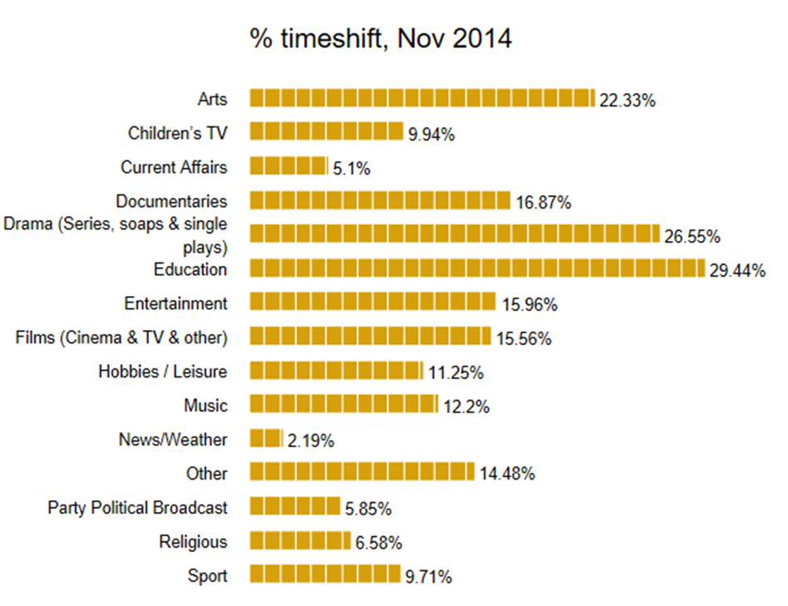

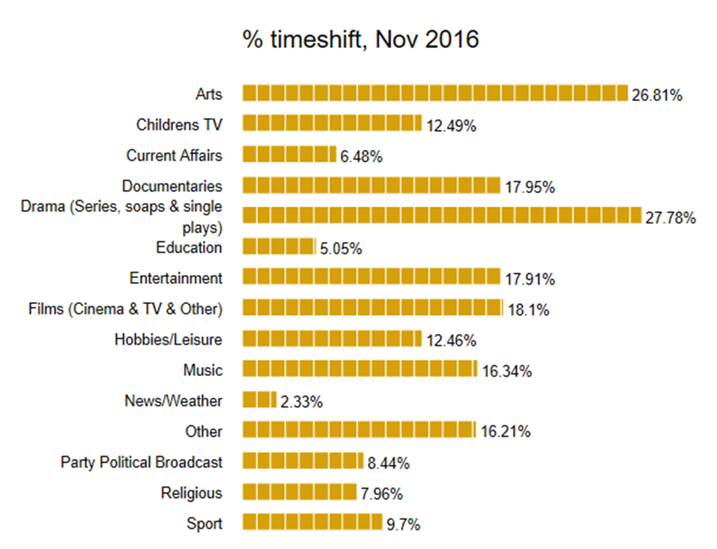

ITV Studios is the groups international content business. It is the largest production company in the UK and produces programming for ITVs own channels and for other broadcasters such as the BBC, Channel 4 and Sky. ITV Studios operates in 6 international locations; the US, Australia, Germany, France, the Netherlands and the Nordics. ITV America is the largest unscripted independent producer of content in the US. In 2015, ITV Studios saw a 33% growth in total revenue, with over half its revenue generated outside the UK. Broadcast and Online services brought in £2,146m and ITV Studios created £1,237m.
Outside of the UK ITV have a number of smaller pay propositions including Cirkus, a subscription VOD sercice that offers the “Best of British” content to international pay platforms which is available in the Nordics and more recently in Iceland. ITV distribute ITV Essentials, an online service for expats, and ITV Choice, a general entertainment channel for emerging markets which was recently launched in South Africa. Shetland a Scottish crime drama produced by ITV Studios UK for the BBC is currently in its third series in the UK and has been sold to 120 countries. Emmerdale has been sold to 139 countries; the chase has been produced in 9 countries and sold to over 130 countries. Thunderbirds are Go! has now been sold to 90 countries, including a 4 series deal with Amazon to debut on prime video in the US. Coronation Street has been sold to 132 countries and Poldark has been sold to 107 countries and has been recommissioned for a second series.
ITV Broadcasting are a subsidiary company of ITV plc and hold 11 regional English and Welsh licenses. The two Scottish licenses are held by STV Central Ltd and STV North Ltd, which are both subsidiaries of STV Group pld. The licenses in Northern Ireland and th Channel Islands are held by UTV Ltd and Channel Television Ltd (Ofcom, 2010). ITV generally has more regional variations than the BBC, however since ITV plc have gained ownership of the channels regional variations have decreased and aren’t more than the minimum requirements set by Ofcom. As part of their broadcasting agreement, Regional ITV companies must provide local news, with the main news at 6pm and regional news after each national news programme. Most of the time, ITV provide extra regional news based on current affairs, entertainment or drama. There is a monthly political programme however most regional programming that isn’t based on news was stopped in 2009 (apart from in Wales and the Channel Islands). Regions include Central, London, Meridian, Wales at Six, West Country and Yorkshire: Calendar. Regional programmes often cover news that includes the weather, sport and school programming.
Ofcom is the communications regulator in the UK. Ofcom is based on a number of Acts of Parliament to ensure than content on the TV, Radio, Video-on-demand services, fixed-line telecoms, mobiles and postal services is adequate for the public. Ofcom’s main focus is to ensure than people in the UK get the best from the communication services available and are protected from unlawful content, or scams etc. Quality is always reviewed by Ofcom so that people aren’t treated unfairly and don’t receive any harm. Ofcom is responsible for making sure the radio stations across the UK are used in the most effective way for the general public and that all content across radio and television appeals to a range of tastes and interests. They ensure businesses can thrive for competition whilst appealing to the general public. Ofcom is funded by fees from regulating broadcasting and communications networks, although the Government does grant them aid as well.
There are several sections of the Ofcom Broadcasting Code that apply to ITV and their shows. Under 18’s are always protected as the 3 main goals of ITV is to satisfy their people. This means that they like to be able to appeal to the majority of audiences, including those under the age of 18 and their parents etc. This also applies to the reduction in harmful and offensive content, respecting all religions and religious beliefs and be accurate within programmes to gain trust of the audience. Fairness is also hugely important, especially to peoples’ opinions and beliefs, and to both animals and humans, as ITV’s second focus is the planet.

